MAKE SKILLED IoT INTERNSHIP

ASSIGNMENT – 13

ARDUINO LOGICAL THINKING TASK

**Automatic lights ON when someone enters room.**

* HERE WE WILL BE USING ARDUINO INTERFACE.
  + COMPONENTS REQUIRED:
  1. ARDUINO UNO BOARD
  2. PC / LAPTOP INSTALLED WITH ARDUINO IDE SOFTWARE
  3. IR SENSOR or PIR SENSOR
  4. LED
  5. JUMPING WIRES
* CIRCUIT DIAGRAM 1

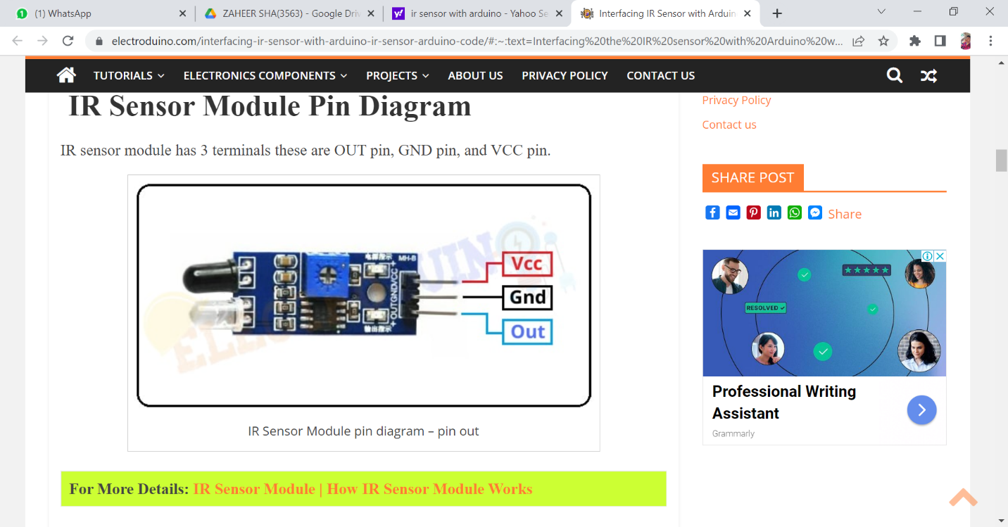

Circuit connections :

|  |  |  |  |  |
| --- | --- | --- | --- | --- |
| IR sensor Vcc Pin | | | + 5v Pin | |
| IR sensor GND Pin | | | GND (ground) pin | |
| IR sensor OUT Pin | | | Digital pin “D3” | |
| LED positive terminal | Digital pin “D13” through the 330 ohm resistor. | |
| LED negative terminal | | | GND pin | | | |

* PROGRAM 1

**int** IRSensor = 3;

**int** LED = 11;

**void** setup()

{

  pinMode (IRSensor, INPUT);

  pinMode (LED, OUTPUT);

  Serial.begin (9600);

}

**void** loop()

{

**int** Sensordata = digitalRead (IRSensor);

  Serial.print("Sensor value:");

  Serial.println(Sensordata);

**if** (Sensordata == 0)

  {

    digitalWrite(LED, HIGH);

    }

**else**

  {

    digitalWrite(LED, LOW);

  }

}

**OR**

* CIRCUIT DIAGRAM 2
* Graphical user interface, diagram

  Description automatically generated

* PROGRAM 1

#define pirPin 2

int calibrationTime = 30;

int buzz = 3; // alieas led pin

long unsigned int lowIn;

long unsigned int pause = 5000;

boolean lockLow = true;

boolean takeLowTime;

int PIRValue = 0;

void setup() {

Serial.begin(9600);

pinMode(buzz, OUTPUT);

pinMode(pirPin, INPUT);

}

void loop() {

PIRSensor();

}

void PIRSensor() {

if(digitalRead(pirPin) == HIGH) {

if(lockLow) {

PIRValue = 1;

lockLow = false;

Serial.println("Motion detected.");

digitalWrite(buzz, HIGH);

delay(3000);

digitalWrite(buzz, LOW);

delay(3000);

}

takeLowTime = true;

}

if(digitalRead(pirPin) == LOW) {

if(takeLowTime){

lowIn = millis();takeLowTime = false;

}

if(!lockLow && millis() - lowIn > pause) {

PIRValue = 0;

lockLow = true;

Serial.println("Motion ended.");

delay(50);

} } }

**By Team : AKULA ZAHEER SHA , TAUFEEQ BASHA & QUIZER SHAH**